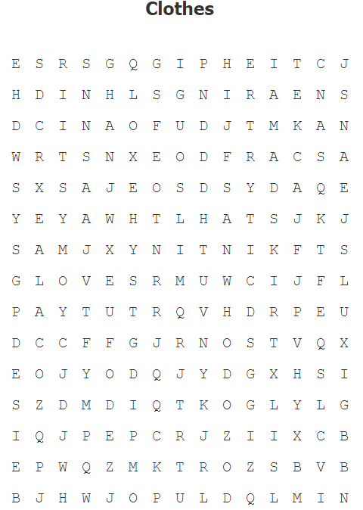

|  |  |  |  |
| --- | --- | --- | --- |
| Español | Ingles | Español | Ingles |
| Aretes |  | Bufanda |  |
| Sombrero |  | Lentes |  |
| Pantalón de mezclilla |  | Sudadera |  |
| Playera |  | Anillo |  |
| Falda |  | Zapato |  |
| Tenis |  | Reloj |  |
| Guantes |  | Chaqueta |  |

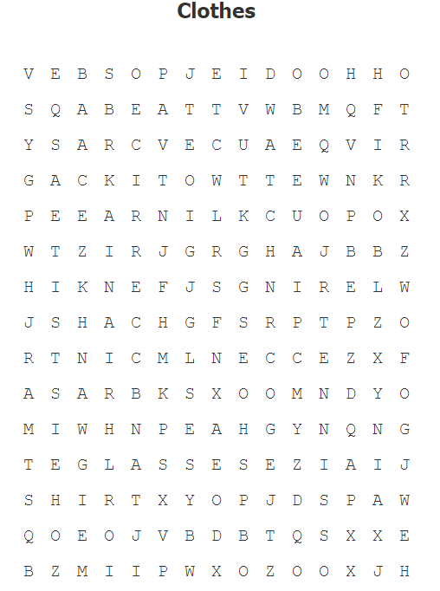

|  |  |  |  |
| --- | --- | --- | --- |
| Español | Ingles | Español | Ingles |
| Aretes |  | Bufanda |  |
| Sombrero |  | Lentes |  |
| Pantalón de mezclilla |  | Sudadera |  |
| Playera |  | Anillo |  |
| Falda |  | Zapato |  |
| Tenis |  | Reloj |  |
| Guantes |  | Chaqueta |  |

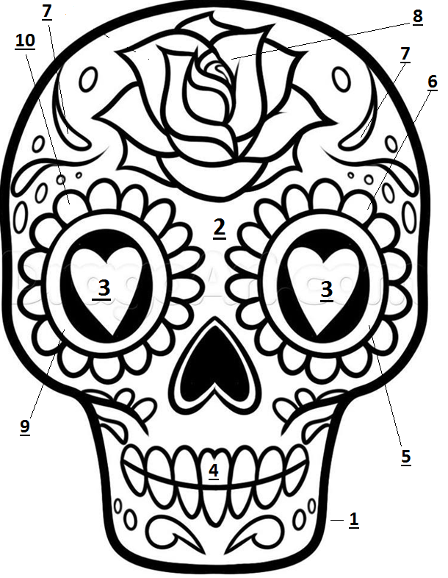

|  |  |  |  |
| --- | --- | --- | --- |
| One | Purple | Two | Yellow |
| Three | Red | Four | Blue |
| Five | Green (Dark) | Six | Green (Light) |
| Seven | Pink | Eight | Red |
| Nine | Orange (Dark) | Ten | Orange (Light) |

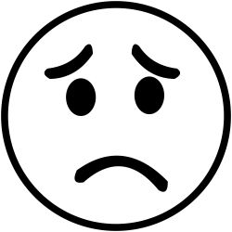 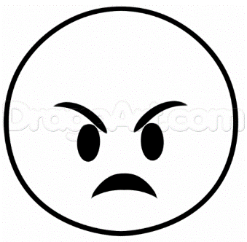 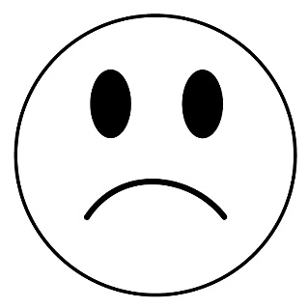

________________________ _________________________ _______________________

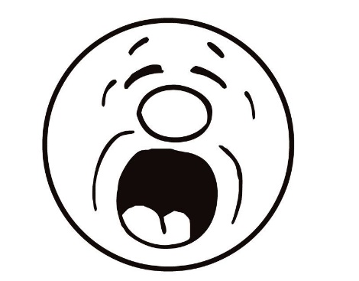 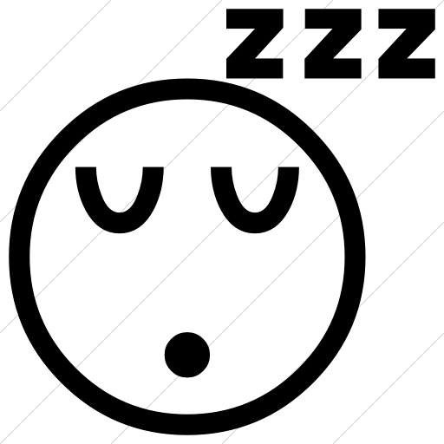 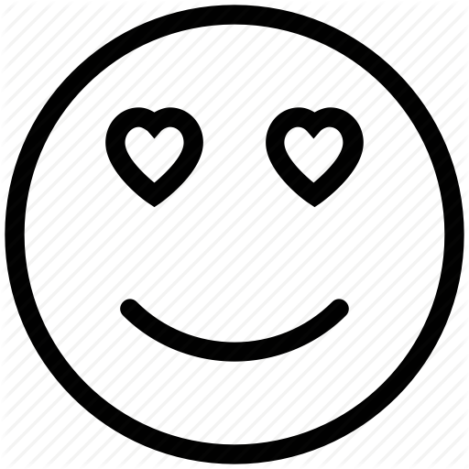

__________________________ __________________________ _______________________

 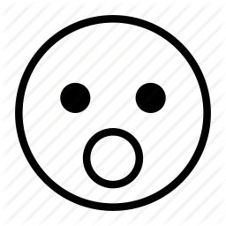 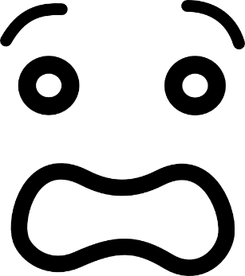

________________________ _____________________________ _____________________

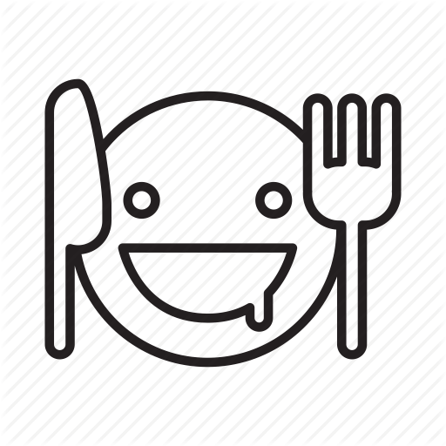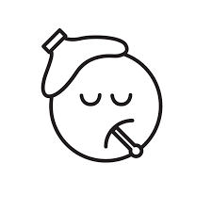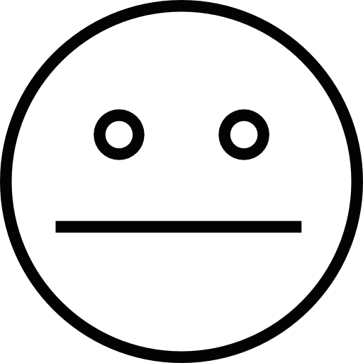

__________________________ ___________________ __________________________

  

________________________ _________________________ _______________________

  

__________________________ __________________________ _______________________

  

________________________ _____________________________ _____________________



__________________________ ___________________ __________________________

Brazos Neck

Knee Ojos

Piernas Mouth

Hombros Hands

Stomach Manos

Pecho Ear

Nariz Chest

Rodillas Shoulders

Cuello Nose

Head Estómago

Oreja Legs

Cabeza Eyes

Boca Arms

Brazos Neck

Knee Ojos

Piernas Mouth

Hombros Hands

Stomach Manos

Pecho Ear

Nariz Chest

Rodillas Shoulders

Cuello Nose

Head Estómago

Oreja Legs

Cabeza Eyes

Boca Arms

